Azure App Service :

**Step 1 : Create an App Service to Host the Web Application**

You're an administrator for your company, which has decided to use Azure cloud services rather than updating its own site hosting infrastructure. You'll facilitate setting up a free tier Application Service Plan and Web Application on a free tier for the developers to familiarize themselves with prior to the actual move.

1. To the right of these instructions, use the **Email**, **Password**, and **Open Azure portal** button provided by this lab to log in to the portal.
2. Under **Azure services** near the top, click on **+ Create a resource**.
3. In the **Search the Marketplace** search box, type in App Service Plan and click on **App Service Plan**.

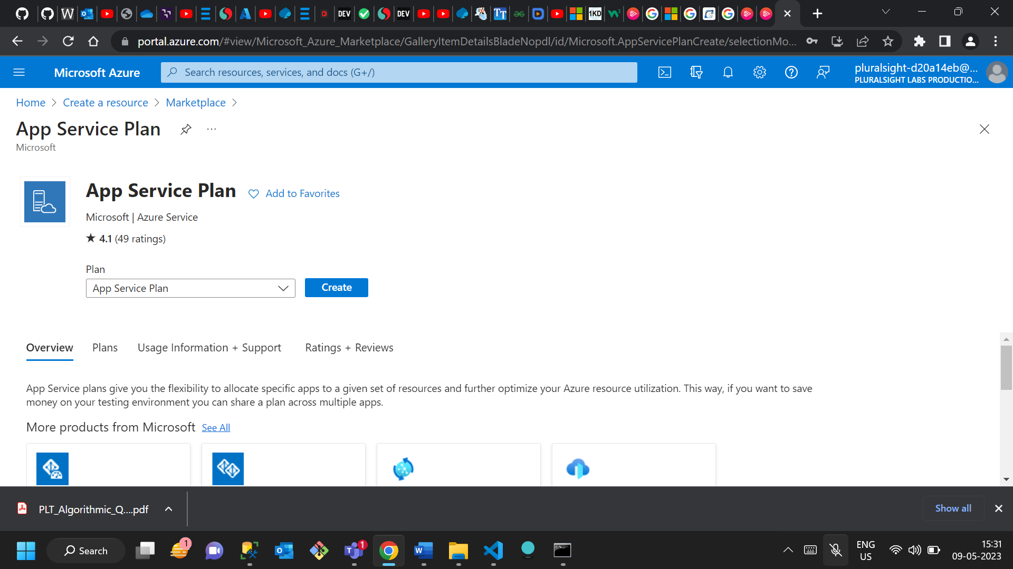

1. Under **App Service Plan**, click **Create**.
2. For the **Resource Group** select pluralsight-resource-group.
3. Set **Name** to Experimental.
4. Set **Operating System** to **Windows**.
5. Set **Region** to **East US**.

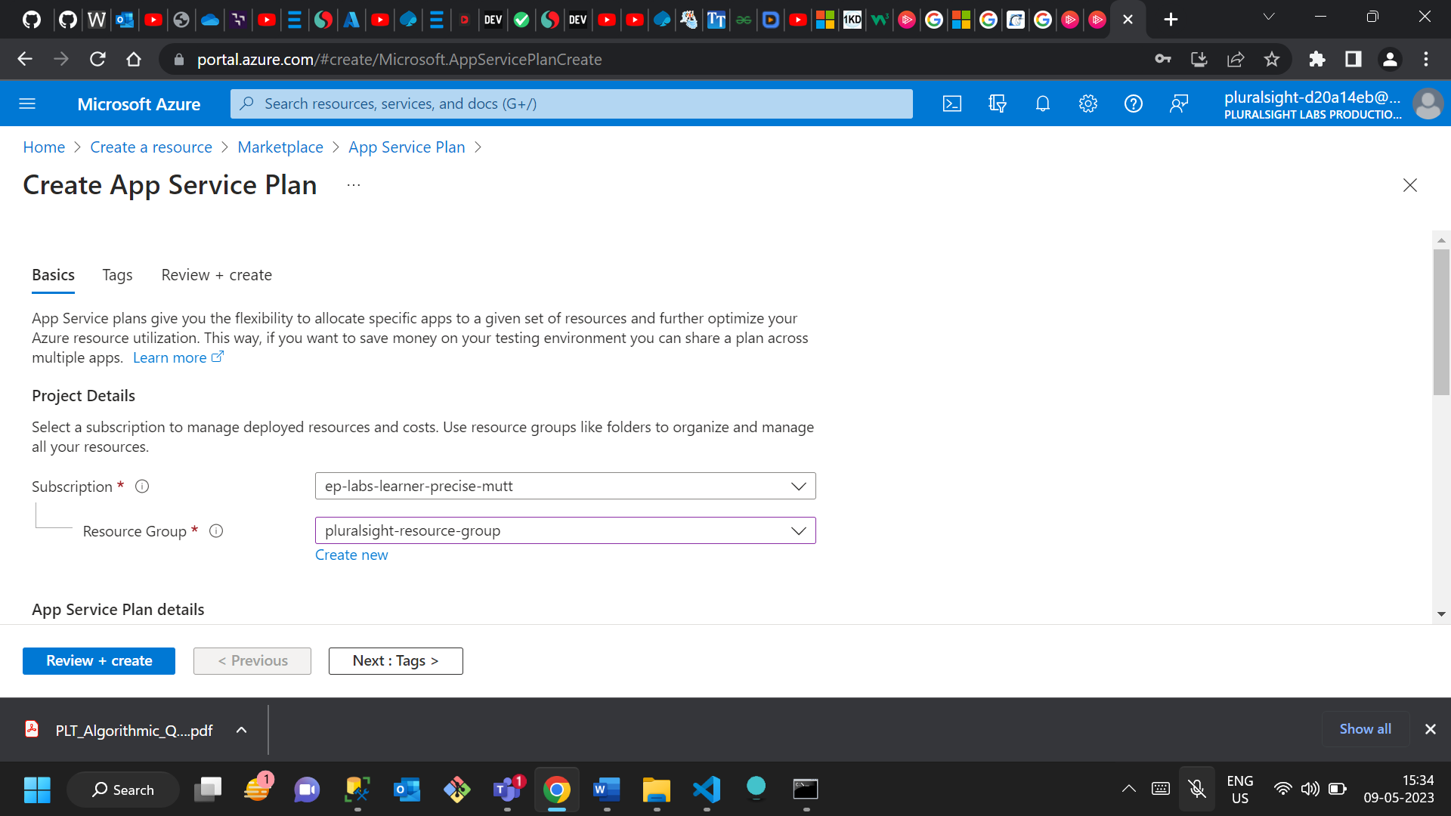

1. Beside **Sku and size**, click on the **Change size** link.
2. In the **Spec Picker**, select **Dev / Test**, then click **F1**, then in the lower-left click **Apply**.
3. At the bottom-left of the page, click **Review + create**.

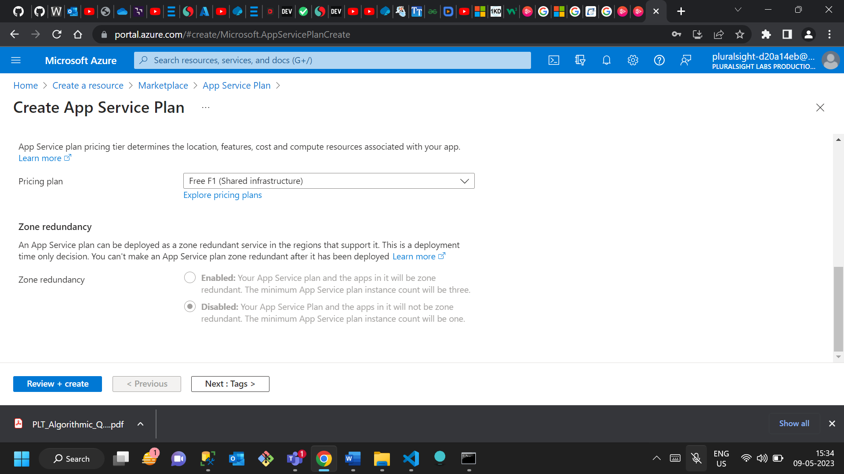

1. At the bottom-left of the page, click **Create**. (You'll need to wait for a few seconds for this to complete.)

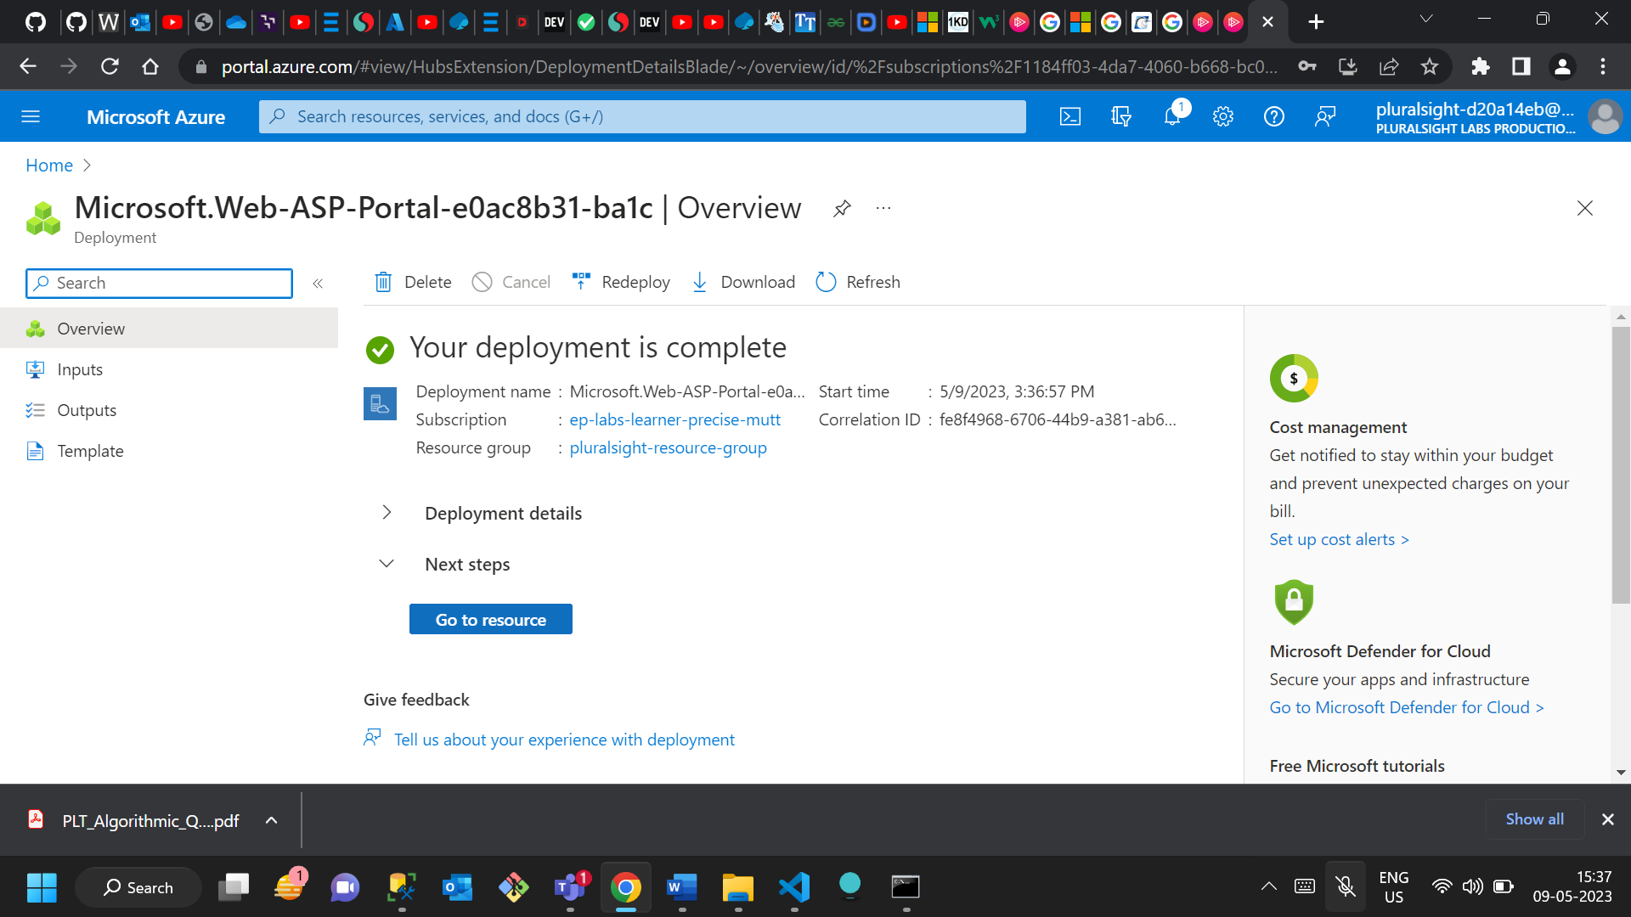

1. Under **Next steps**, click on **Go to resource**.

You will be presented with an **Experimental** **App Service plan** that should have the **App Service Plan** value of **Experimental (F1: Free)**.

**Step 2 : Create a Web Application**

1. In the upper-left click on **Microsoft Azure**, then click **+ Create a resource**.
2. In the **Search the Marketplace** search box, type in Web App and click on **Web App**.
3. Under **Web App**, click **Create**.

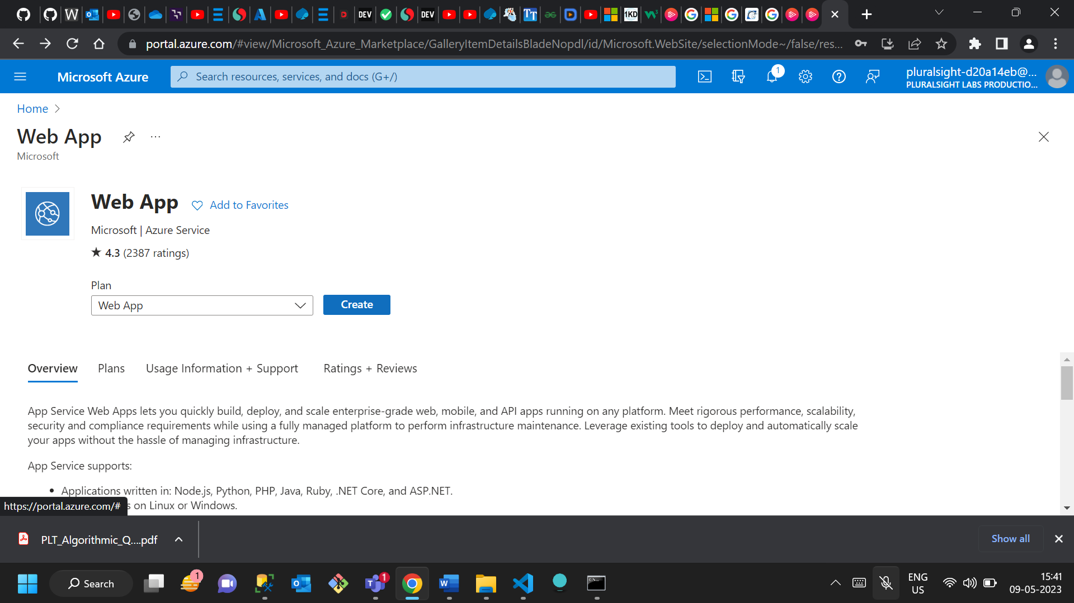

1. Set **Resource Group** to **pluralsight-resource-group**.
2. Set **Name** to **ps-web-app.**

*Note:* The name needs to be unique, so if upon clicking away from the field you get a **The app name ps-web-app** **is not available** message, add a suffix with random letters and numbers. For example, ps-web-app-12hkj21.

1. Set **Publish** to **Code**.
2. Set **Runtime Stack** to **.NET Core 3.1 (LTS)** and **Operating System** to **Windows**.
3. Set **Region** to **East US**.
4. In the bottom-left, click on **Review + create**.

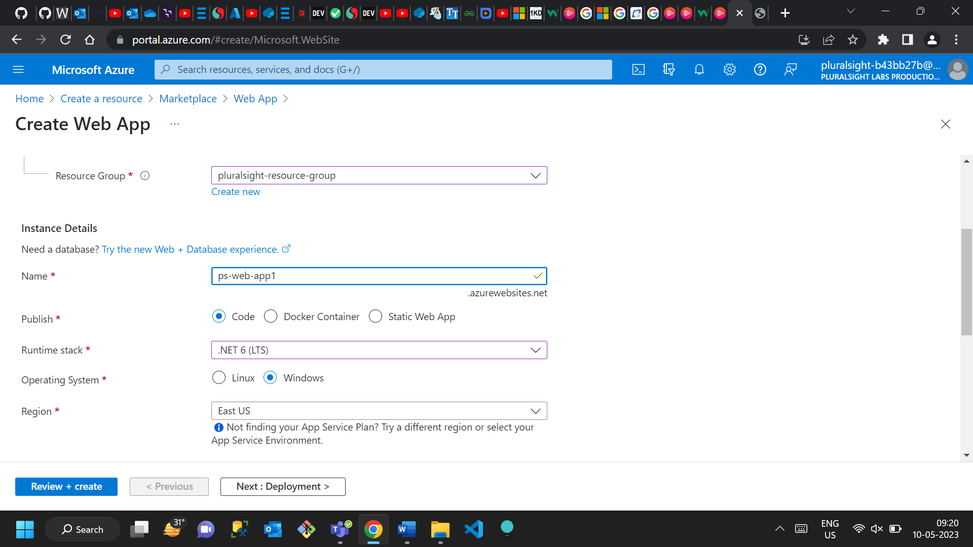

1. In the bottom-left, click on **Create**. (You'll need to wait for about one to three minutes for the deployment to complete, indicated by the **in progress** message changing to a **Your deployment is complete** message.)

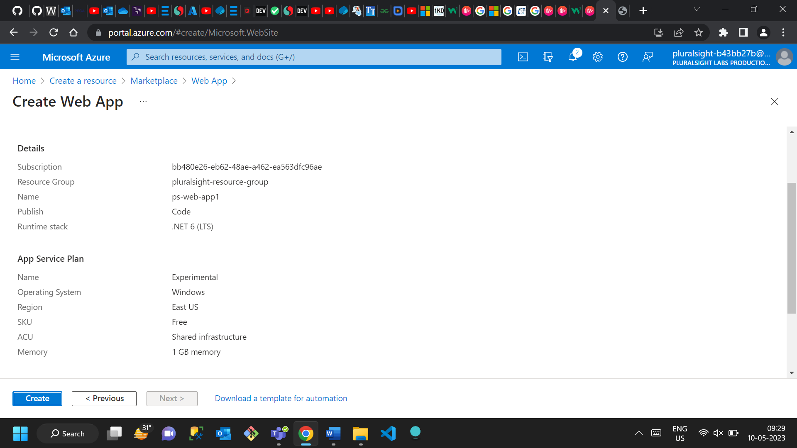

1. Once the deployment has completed, under **Next steps** click on **Go to resource**.

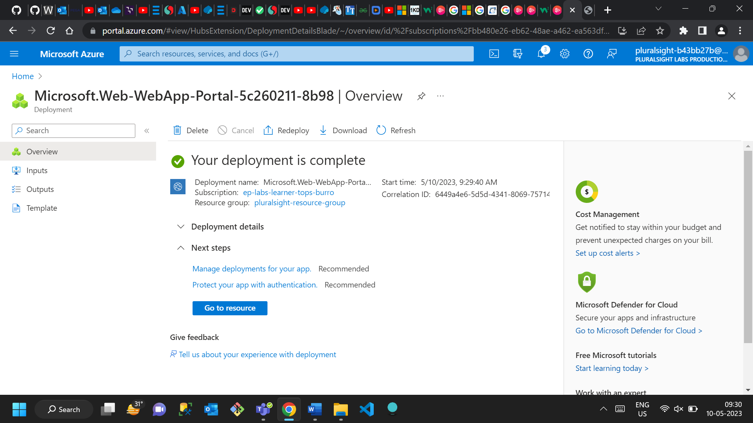

You will be presented with a **ps-web-app** page (or one with the random suffix you chose, for example ps-web-app-12hk21). In addition to this, you will also see the **App Service Plan** field with a value of **Experimental (F1: Free)**, and when you click on the **URL** field's link, a new tab will open that towards the bottom of the page that says **Hey, App Service developers! Your app service is up and running.**